**Name : Tanishq Thuse**

**Branch : CS(AI)**

**Year : SY**

**Div : B**

**Roll no. : 60**

**PRN : 12310237**

**Title : OS Assignment-3 Classical Problems of Synchronization**

**Q1) Producer-Consumer Problem**

**Code :**

#include <stdio.h>

#include <stdlib.h>

#include <pthread.h>

#include <semaphore.h>

#define BUFFER_SIZE 5

// Shared buffer and semaphores

int buffer[BUFFER_SIZE];

int in = 0, out = 0;

sem_t empty, full, mutex;

// Producer thread function

void* producer(void* arg) {

for (int i = 0; i < 10; i++) {

sem_wait(&empty); // Wait for empty slot

sem_wait(&mutex); // Enter critical section

buffer[in] = i; // Produce an item

printf("Produced: %d\n", i);

in = (in + 1) % BUFFER_SIZE;

sem_post(&mutex); // Exit critical section

sem_post(&full); // Signal that buffer has an item

}

return NULL;

}

// Consumer thread function

void* consumer(void* arg) {

for (int i = 0; i < 10; i++) {

sem_wait(&full); // Wait for an item

sem_wait(&mutex); // Enter critical section

int item = buffer[out]; // Consume an item

printf("Consumed: %d\n", item);

out = (out + 1) % BUFFER_SIZE;

sem_post(&mutex); // Exit critical section

sem_post(&empty); // Signal that buffer has an empty slot

}

return NULL;

}

int main() {

pthread_t prod, cons;

// Initialize semaphores

sem_init(&empty, 0, BUFFER_SIZE); // Buffer starts empty

sem_init(&full, 0, 0); // Buffer starts with no items

sem_init(&mutex, 0, 1); // Mutex for critical section

// Create producer and consumer threads

pthread_create(&prod, NULL, producer, NULL);

pthread_create(&cons, NULL, consumer, NULL);

// Wait for threads to finish

pthread_join(prod, NULL);

pthread_join(cons, NULL);

// Destroy semaphores

sem_destroy(&empty);

sem_destroy(&full);

sem_destroy(&mutex);

return 0;

}

Output :

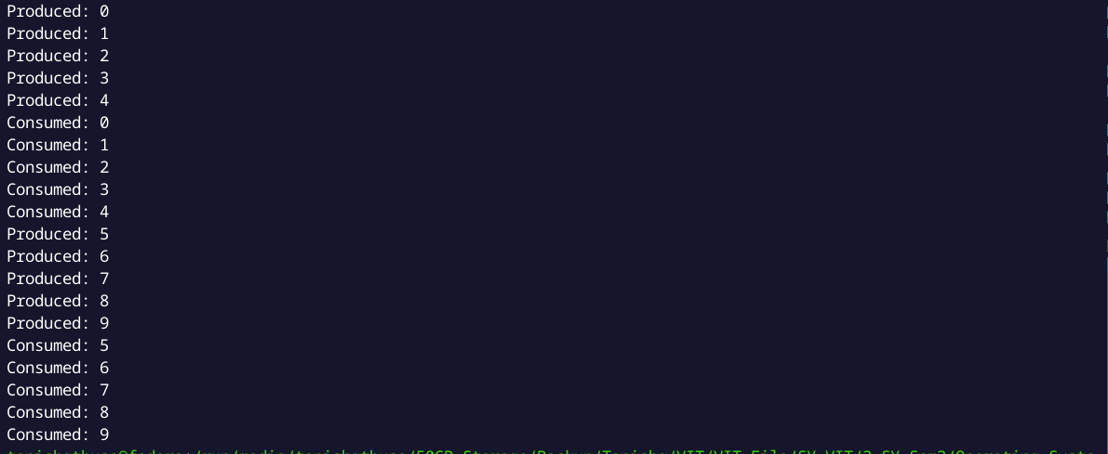

**Q2) Reader-Writer Problem**

**Code :**

// Reader-Writer problem using monitors

#include <iostream>

#include <pthread.h>

#include <unistd.h>

using namespace std;

class monitor {

private:

// no. of readers

int rcnt;

// no. of writers

int wcnt;

// no. of readers waiting

int waitr;

// no. of writers waiting

int waitw;

// condition variable to check whether reader can read

pthread_cond_t canread;

// condition variable to check whether writer can write

pthread_cond_t canwrite;

// mutex for synchronization

pthread_mutex_t condlock;

public:

monitor()

{

rcnt = 0;

wcnt = 0;

waitr = 0;

waitw = 0;

pthread_cond_init(&canread, NULL);

pthread_cond_init(&canwrite, NULL);

pthread_mutex_init(&condlock, NULL);

}

// mutex provide synchronization so that no other thread

// can change the value of data

void beginread(int i)

{

pthread_mutex_lock(&condlock);

// if there are active or waiting writers

if (wcnt == 1 || waitw > 0) {

// incrementing waiting readers

waitr++;

// reader suspended

pthread_cond_wait(&canread, &condlock);

waitr--;

}

// else reader reads the resource

rcnt++;

cout << "reader " << i << " is reading\n";

pthread_mutex_unlock(&condlock);

pthread_cond_broadcast(&canread);

}

void endread(int i)

{

// if there are no readers left then writer enters monitor

pthread_mutex_lock(&condlock);

if (--rcnt == 0)

pthread_cond_signal(&canwrite);

pthread_mutex_unlock(&condlock);

}

void beginwrite(int i)

{

pthread_mutex_lock(&condlock);

// a writer can enter when there are no active

// or waiting readers or other writer

if (wcnt == 1 || rcnt > 0) {

++waitw;

pthread_cond_wait(&canwrite, &condlock);

--waitw;

}

wcnt = 1;

cout << "writer " << i << " is writing\n";

pthread_mutex_unlock(&condlock);

}

void endwrite(int i)

{

pthread_mutex_lock(&condlock);

wcnt = 0;

// if any readers are waiting, threads are unblocked

if (waitr > 0)

pthread_cond_signal(&canread);

else

pthread_cond_signal(&canwrite);

pthread_mutex_unlock(&condlock);

}

}

// global object of monitor class

M;

void* reader(void* id)

{

int c = 0;

int i = *(int*)id;

// each reader attempts to read 5 times

while (c < 5) {

usleep(1);

M.beginread(i);

M.endread(i);

c++;

}

}

void* writer(void* id)

{

int c = 0;

int i = *(int*)id;

// each writer attempts to write 5 times

while (c < 5) {

usleep(1);

M.beginwrite(i);

M.endwrite(i);

c++;

}

}

int main()

{

pthread_t r[5], w[5];

int id[5];

for (int i = 0; i < 5; i++) {

id[i] = i;

// creating threads which execute reader function

pthread_create(&r[i], NULL, &reader, &id[i]);

// creating threads which execute writer function

pthread_create(&w[i], NULL, &writer, &id[i]);

}

for (int i = 0; i < 5; i++) {

pthread_join(r[i], NULL);

}

for (int i = 0; i < 5; i++) {

pthread_join(w[i], NULL);

}

}

Output :

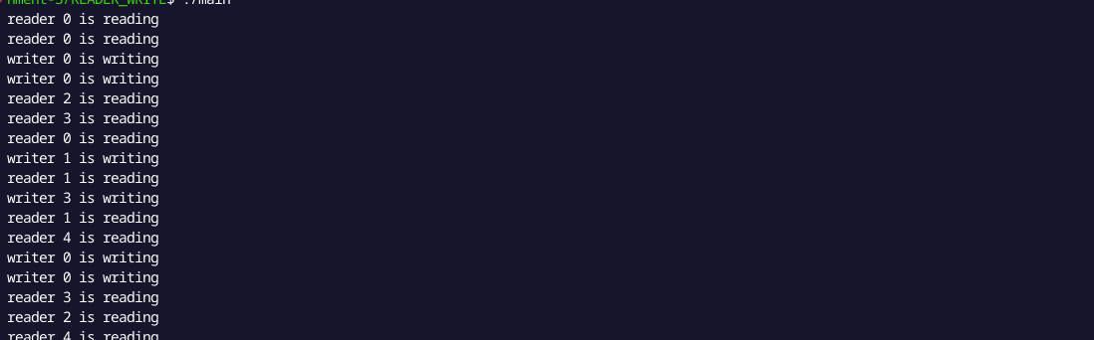

**Q3) Dining Philosopher Problem**

**Code :**

#include <iostream>

#include <thread>

#include <mutex>

#include <condition_variable>

#define N 5

#define THINKING 2

#define HUNGRY 1

#define EATING 0

#define LEFT (phnum + 4) % N

#define RIGHT (phnum + 1) % N

int state[N];

int phil[N] = { 0, 1, 2, 3, 4 };

std::mutex mutex;

std::condition_variable S[N];

void test(int phnum)

{

if (state[phnum] == HUNGRY

&& state[LEFT] != EATING

&& state[RIGHT] != EATING) {

// state that eating

state[phnum] = EATING;

std::this_thread::sleep_for(std::chrono::milliseconds(2000));

std::cout << "Philosopher " << phnum + 1 << " takes fork " << LEFT + 1 << " and " << phnum + 1 << std::endl;

std::cout << "Philosopher " << phnum + 1 << " is Eating" << std::endl;

// notify the philosopher that he can start eating

S[phnum].notify_all();

}

}

// take up chopsticks

void take_fork(int phnum)

{

std::unique_lock<std::mutex> lock(mutex);

// state that hungry

state[phnum] = HUNGRY;

std::cout << "Philosopher " << phnum + 1 << " is Hungry" << std::endl;

// eat if neighbours are not eating

test(phnum);

// if unable to eat wait to be signalled

S[phnum].wait(lock);

std::this_thread::sleep_for(std::chrono::milliseconds(1000));

}

// put down chopsticks

void put_fork(int phnum)

{

std::unique_lock<std::mutex> lock(mutex);

// state that thinking

state[phnum] = THINKING;

std::cout << "Philosopher " << phnum + 1 << " putting fork " << LEFT + 1 << " and " << phnum + 1 << " down" << std::endl;

std::cout << "Philosopher " << phnum + 1 << " is thinking" << std::endl;

test(LEFT);

test(RIGHT);

}

void philosopher(int num)

{

while (true) {

take_fork(num);

put_fork(num);

}

}

int main()

{

std::thread threads[N];

for (int i = 0; i < N; i++) {

threads[i] = std::thread(philosopher, i);

std::cout << "Philosopher " << i + 1 << " is thinking" << std::endl;

}

for (int i = 0; i < N; i++)

threads[i].join();

return 0; }

**Output :**

